**Дата**: 11.12.2024

**Клас**: 7-Б

**Предмет**: англійська мова

**Тема:** What`s on? Улюблені телепрограми.

**Мета:** : формувати навички вживання лексичних одиниць по темі; удосконалювати навички читання, аудіювання й усного монологічного мовлення; розвивати пізнавальні інтереси учнів; виховувати інтерес до самостійного пошуку потрібної інформації, а також загальну культуру учнів.

**Вчитель**: Руда Д.В.

Хід уроку

1.Greeting

Good afternoon, guys! I’m glad to see you. Are you ready to start our lesson? All set?

2. Wаrm up / Listening

Уважно слухати аудіо трек і дати відповідь на питання вчителя <https://www.youtube.com/watch?v=rYaZr7pKKSY> .

3. Speaking

Дати усно відповіді на питання :

Where do you watch videos more often? On a phone, computer, or television?

What’s your favorite TV channel?

Do you have a favorite TV show these days? Do you see every episode?

How many hours of television do you watch each week? Is it too much?

In your house, who watches the most television? What kind of shows do they watch?

Watching a show or movie with friends or family can be fun. What have you enjoyed watching with other people?

In your home, do people fight over the remote control? Do you like to have control of the television?

Big televisions are not as expensive as they used to be. How big do you want a TV to be? How big is too big?

Full HD, 4K, 8K - what’s next? Do you have to have the latest television technology?

TV channels sometimes have many advertisements. How do you feel about ads? Do you usually watch them or change the channel?

Have you ever been on TV? If not, do you know anyone that has?

What’s your favorite website for watching videos?

Do you prefer to watch short or long videos online? What kinds of videos do you usually watch?

When you like a video online, do you feel like you should share it? Who do you want to share it with?

Have you seen any viral videos lately? What kinds of videos have been going around?

Have you ever uploaded a video to a public website? What was in the video? How many views did it get?

Do you have any favorite YouTubers? What kind of content do they make?

Have you thought about making a YouTube channel? What would be the subject or purpose of your content?

Have you ever streamed yourself online? What were you doing?

Have you got stuck watching videos and found it difficult to sleep? What’s wrong with this kind of habit?

There are so many cameras in the world these days that a lot of things get caught on video. When is this good?

4. Повторення

Повторити possessive pronouns .

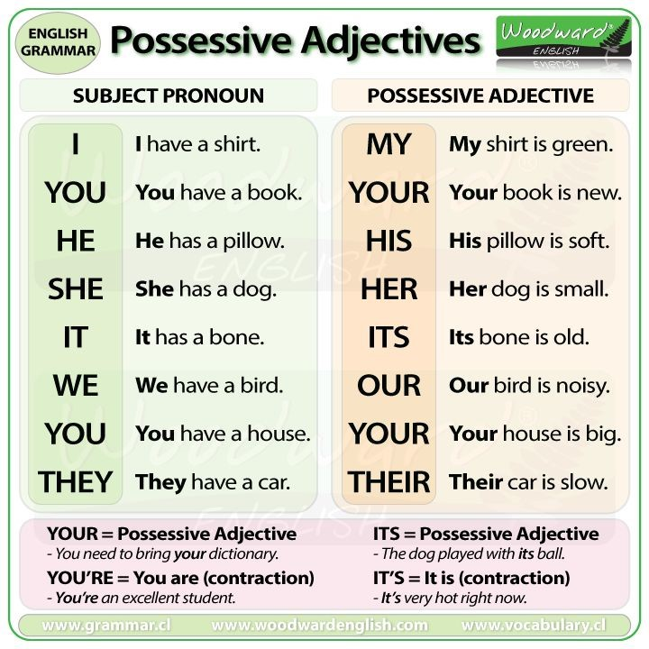

Виконати вправу на possessive pronouns .

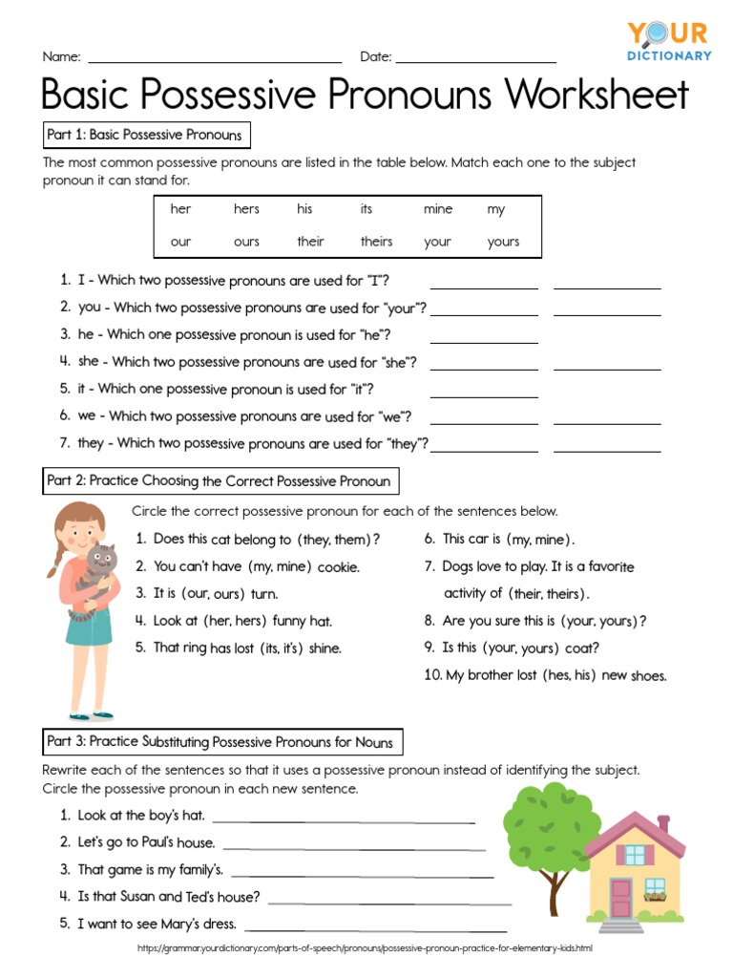

5. Writing

Виконати письмово вправу E /F стр 109.

6. Homework

1. Виконати вправу G стр 109.